Arithmetic operations between 2 numbers

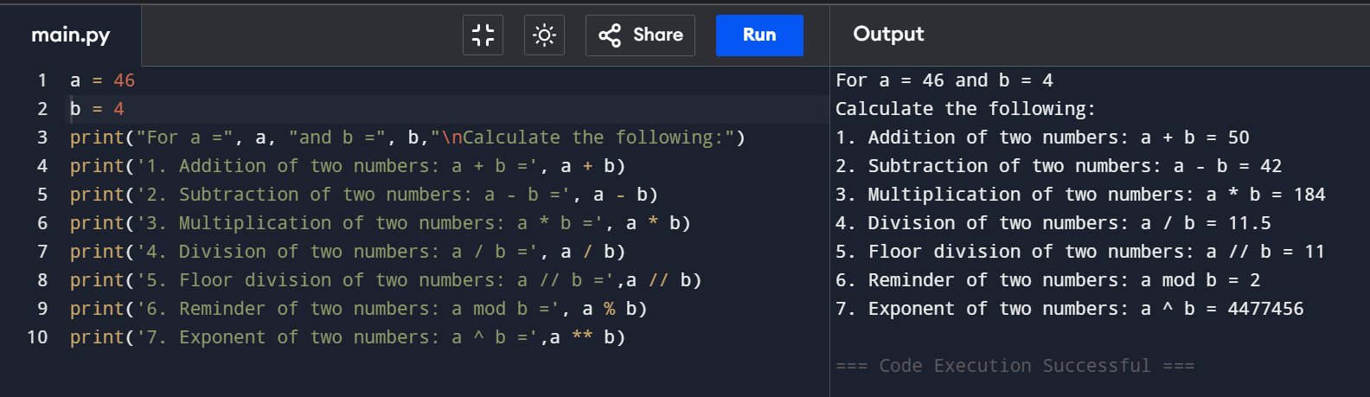

Comparison operations between 2 numbers

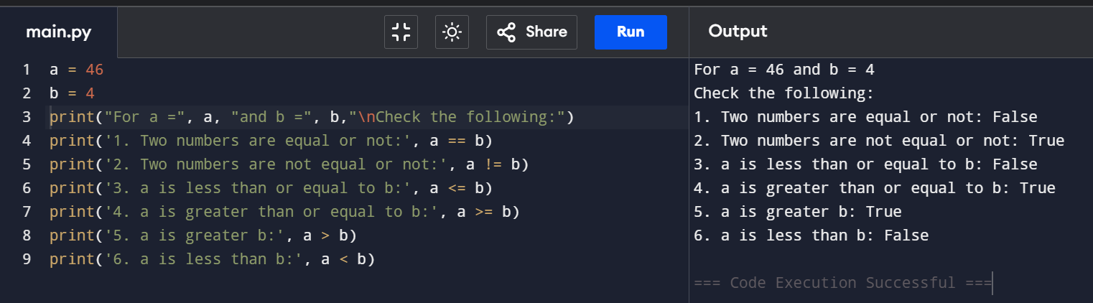

Assignment operators

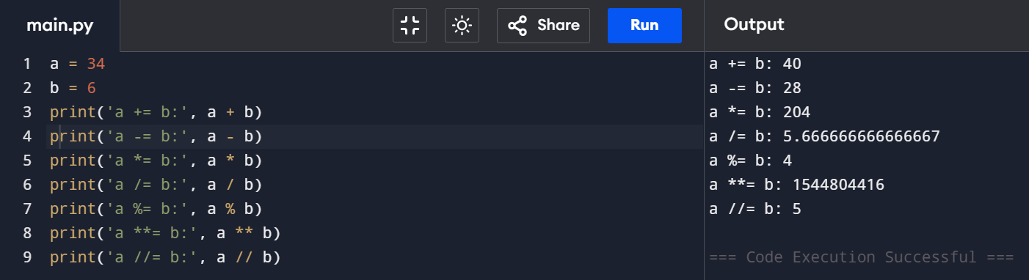

Bitwise operation between 2 numbers

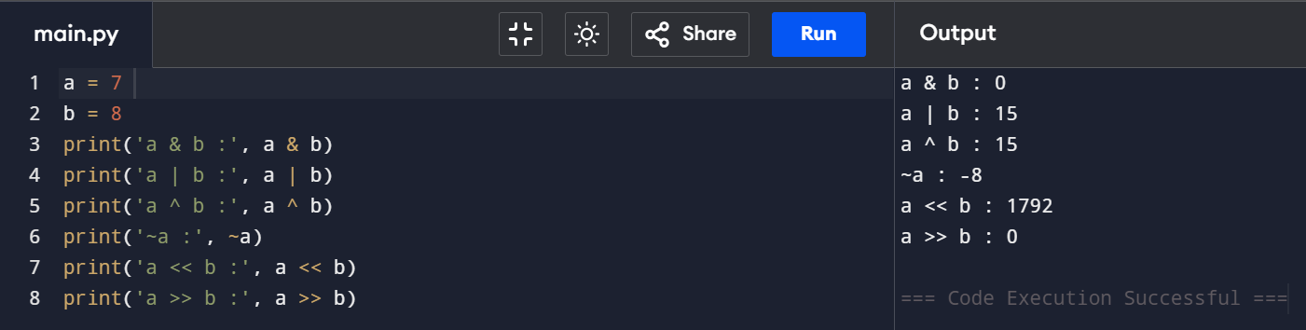

Logical operators

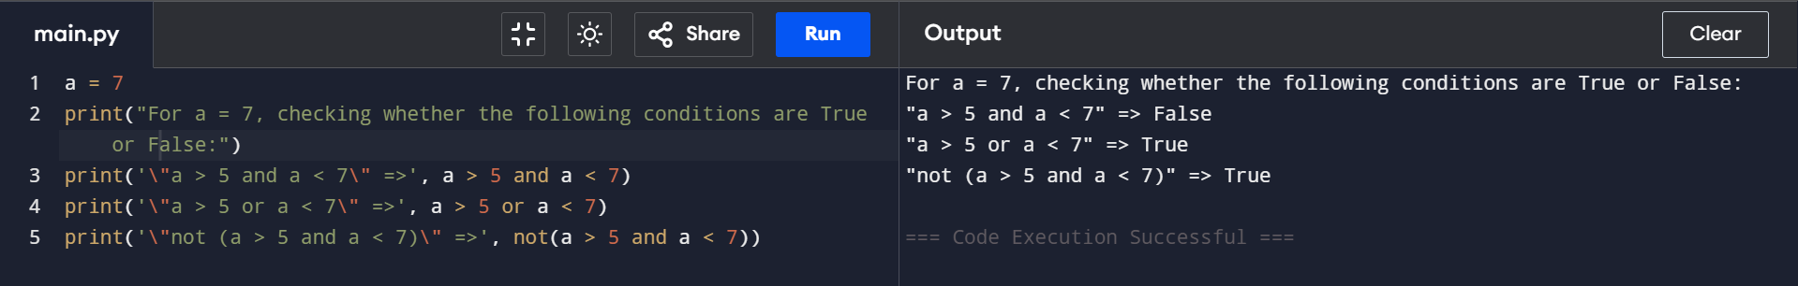

Membership operators

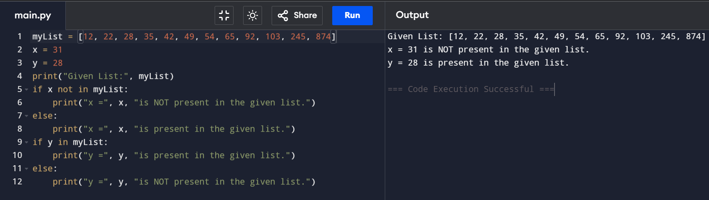

Identity operators

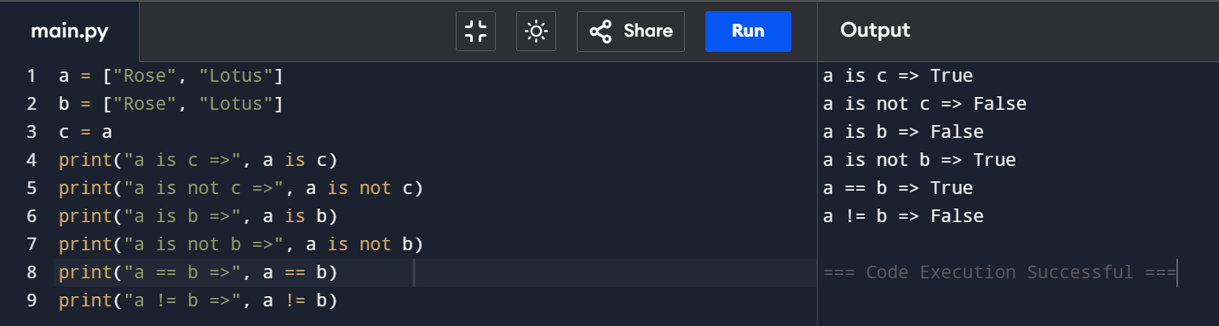

Reverse a string using for loop

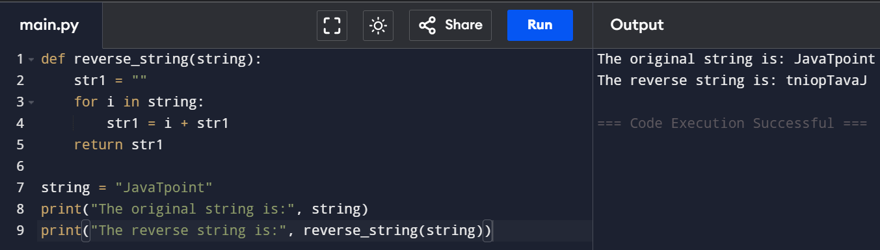

Reverse a string using while loop

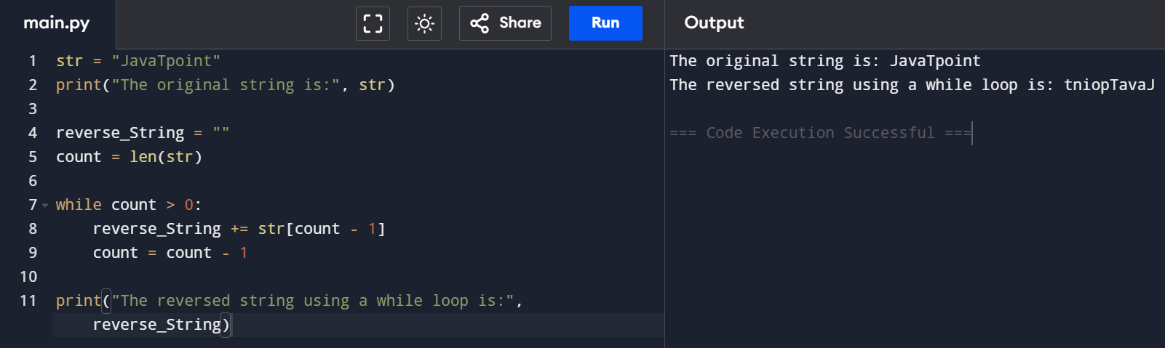

Reverse a string using slice operator

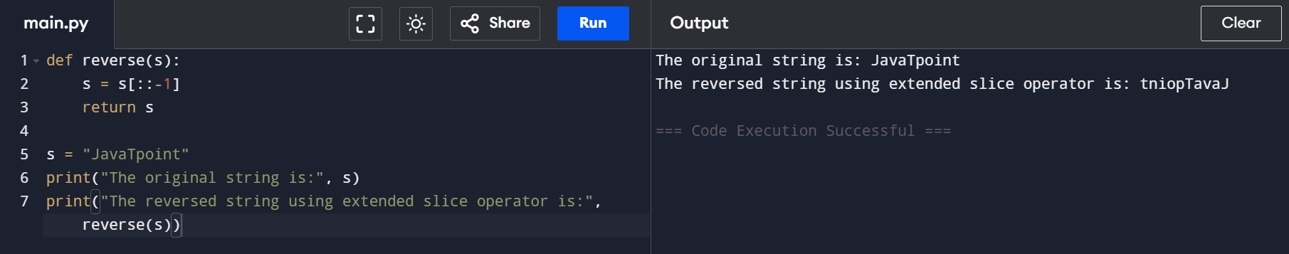

Reverse function using join

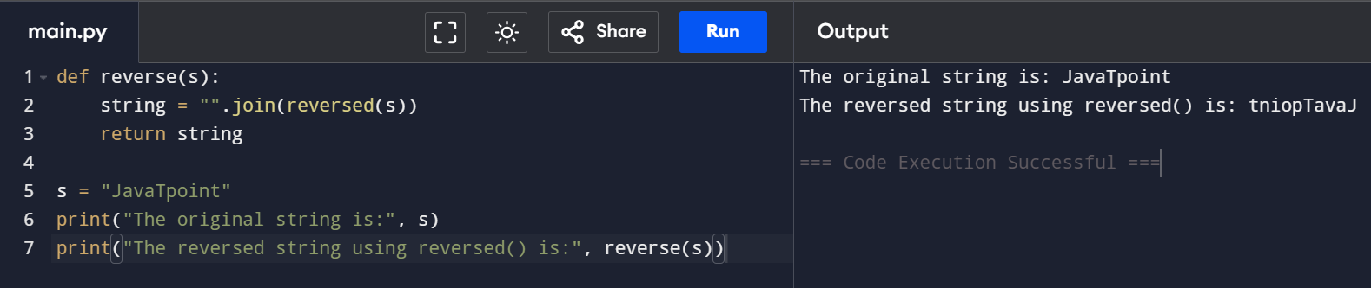

Reverse using recursion

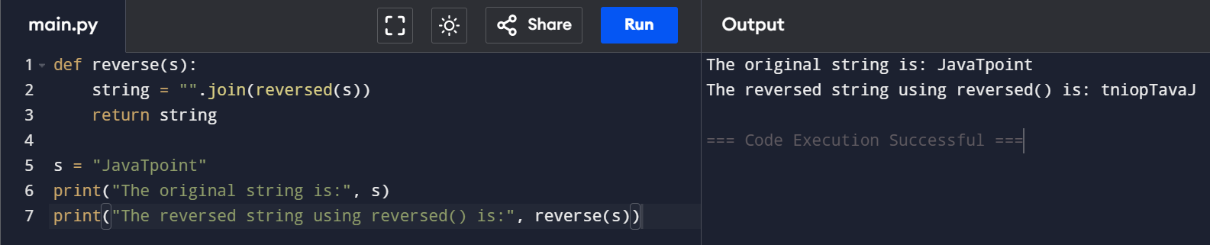

Read a csv file in python

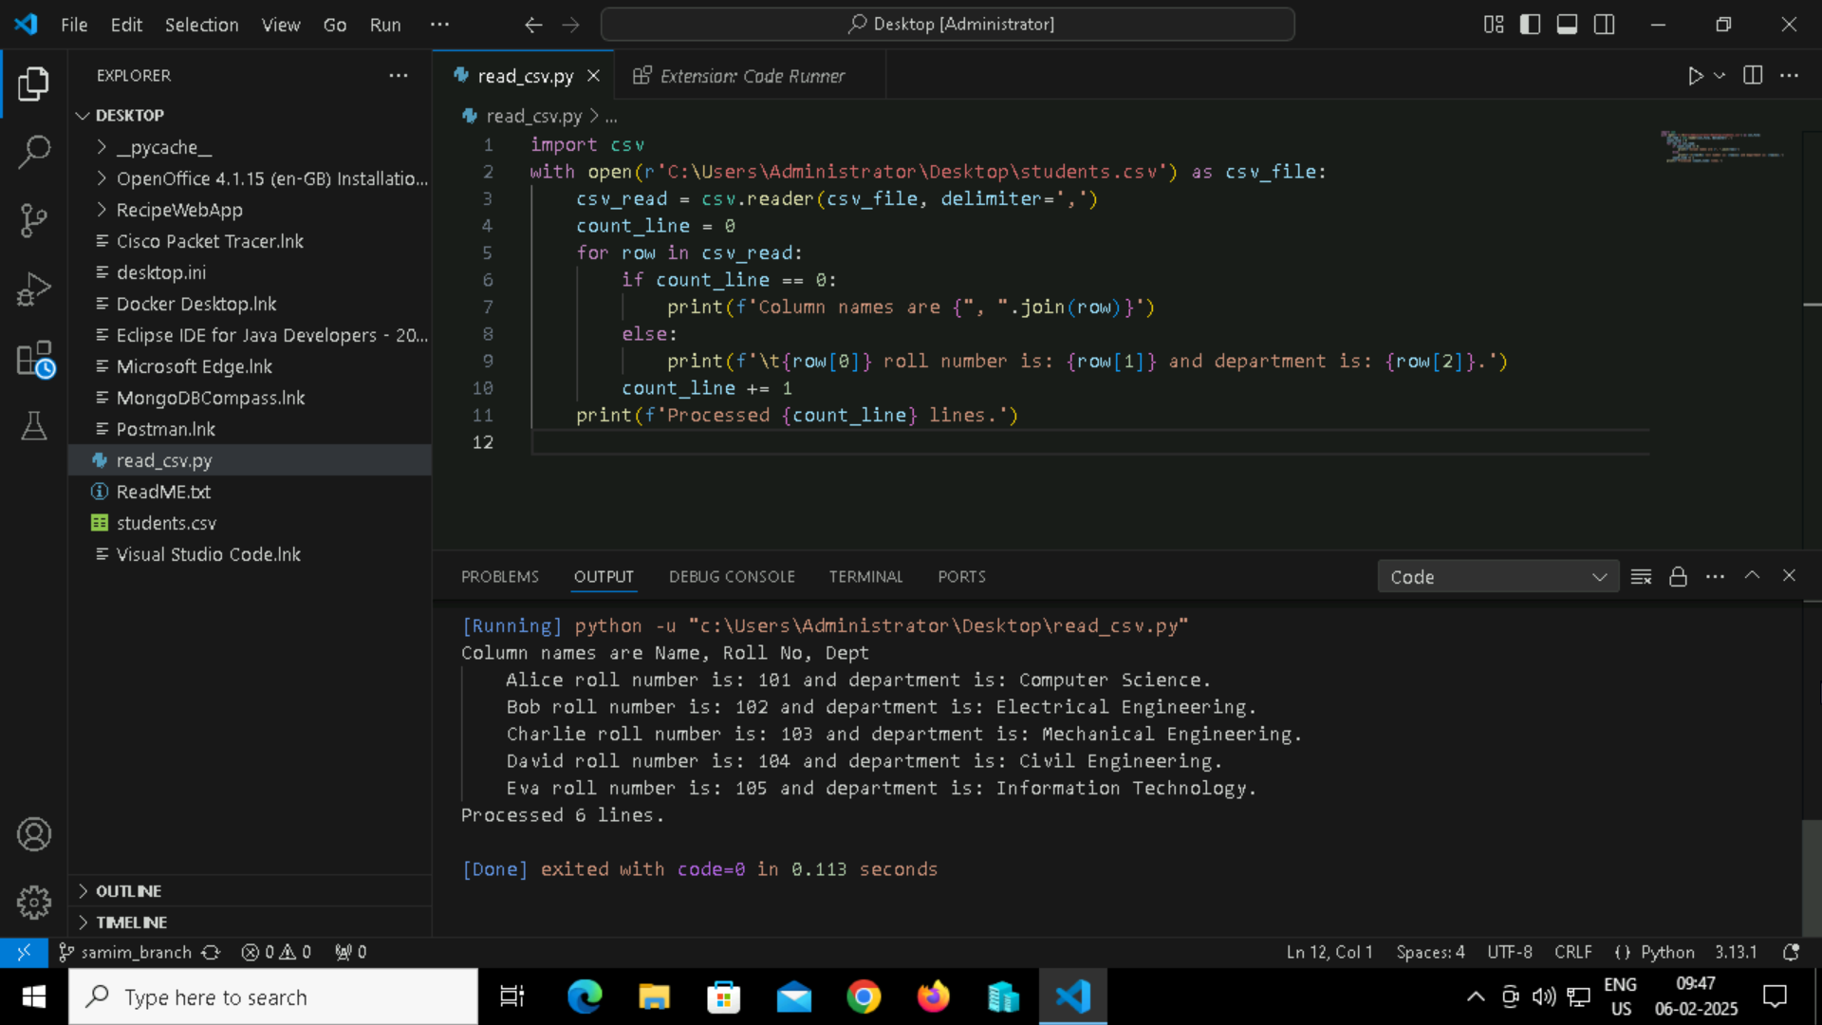

Simple python program to understand if statement

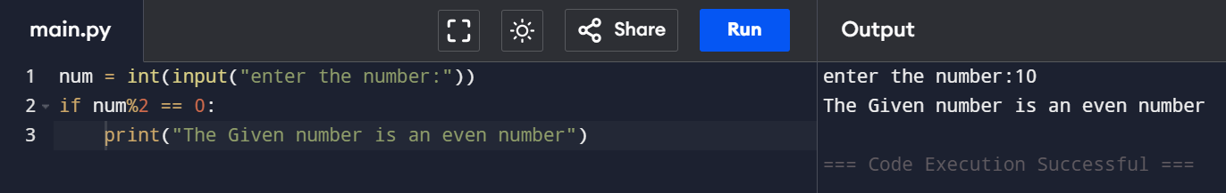

Program to print largest of 3 numbers

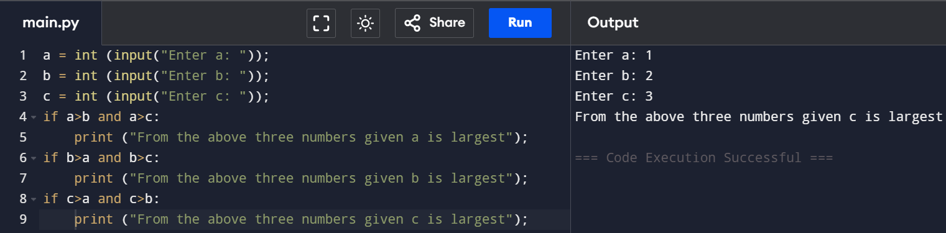

Program to check whether a person is eligible to vote or not

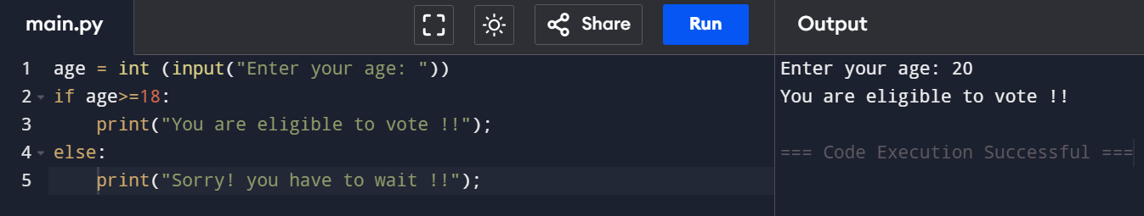

Program to check if the given number is even or odd

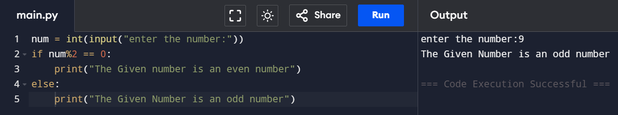

Python program 1 elif statement

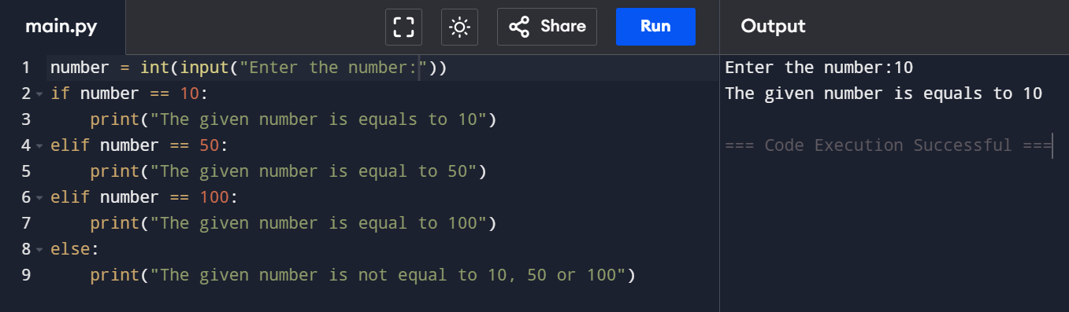

Python program 2 elif statement

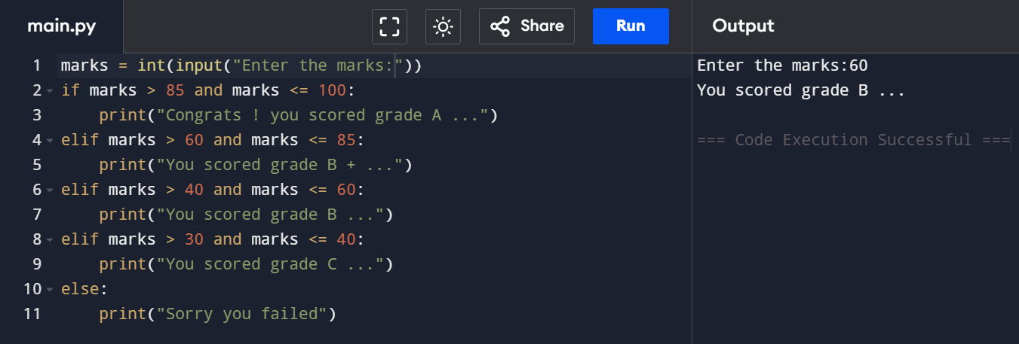

List of squares using for loop

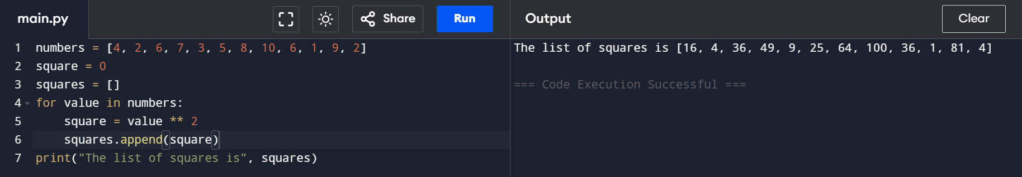

Using loop in string manipulation

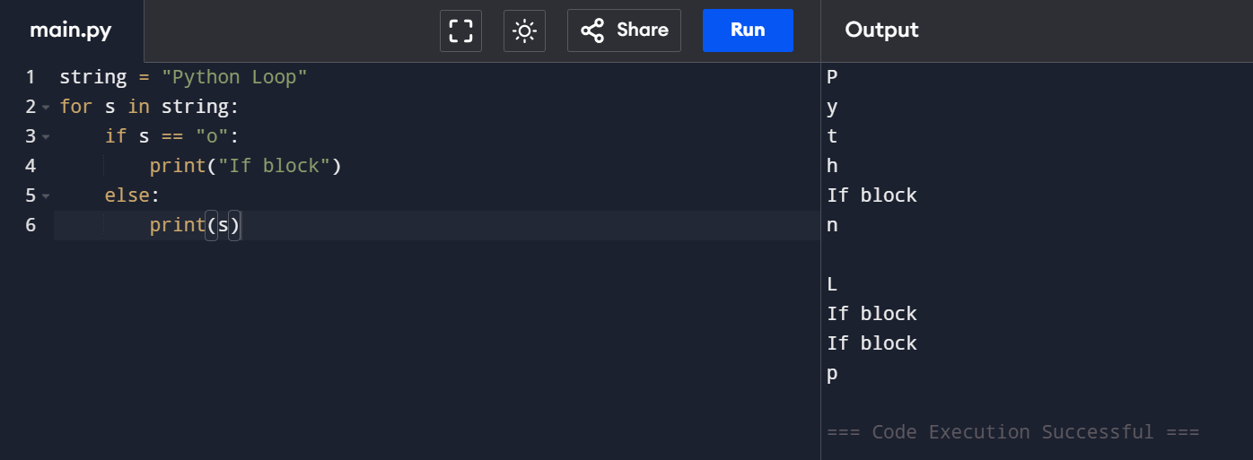

Using else statement with for loop

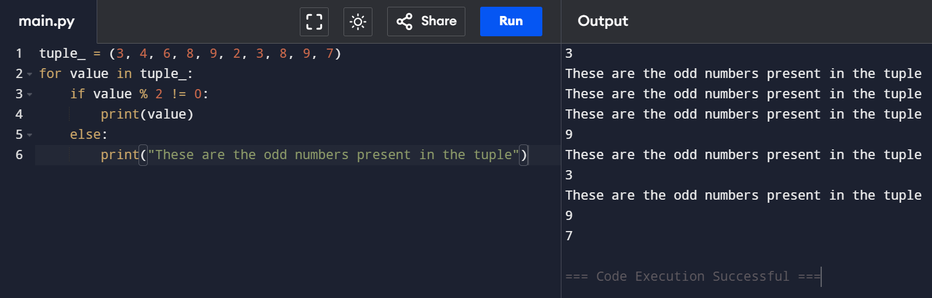

Range function

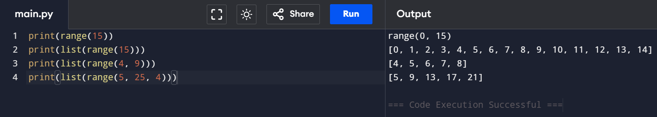

Python program to iterate over a sequence using with the help of indexing

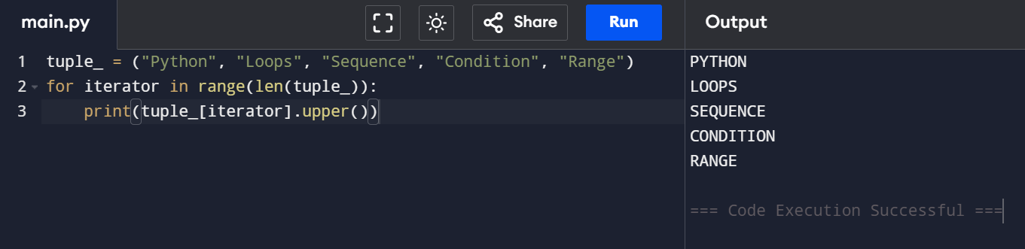

While loop

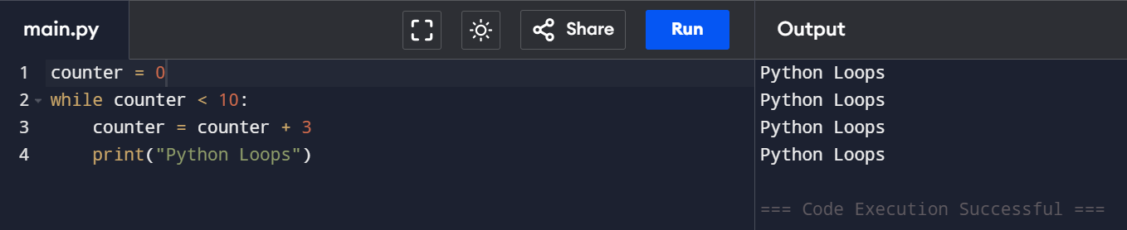

Else statement inside while loop

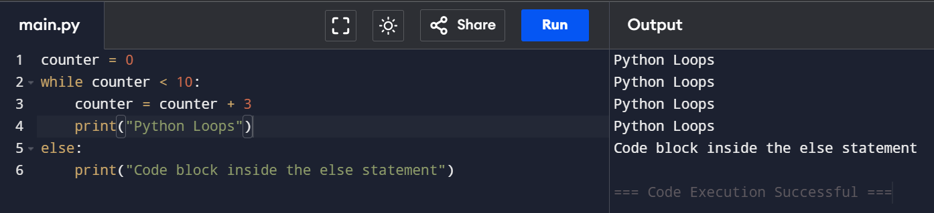

Single statement while block

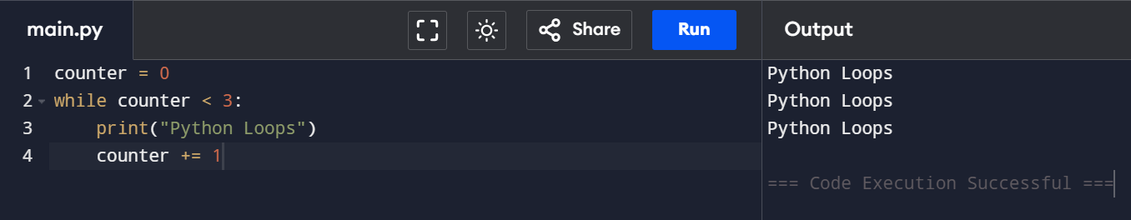

Continue statement

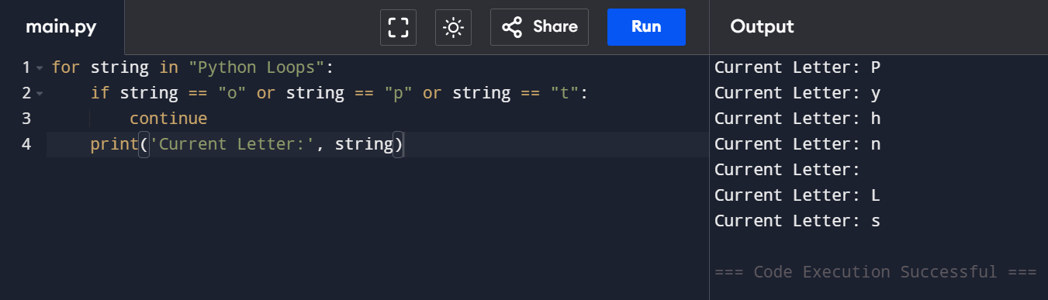

Break statement

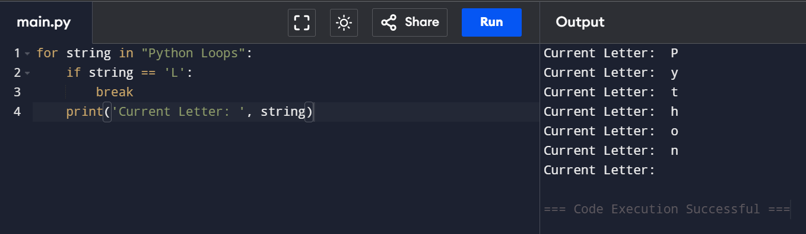

Pass statement

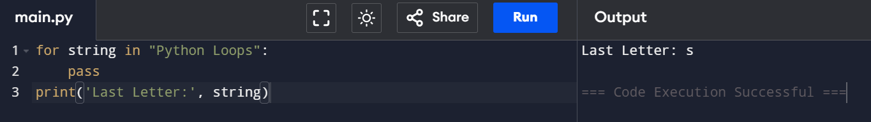

Code to find the sum of squares of each element of the list using for loop

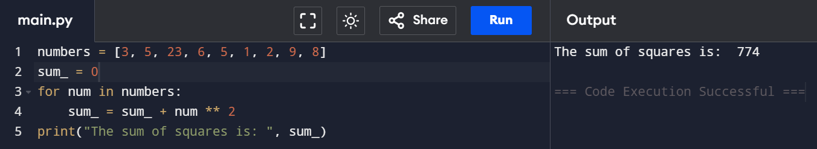

Code to find the sum of squares of each element of the list using for loop

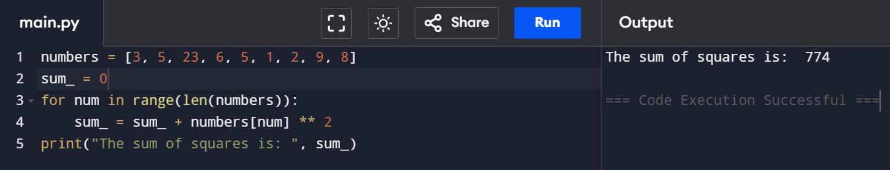

code to print marks of a student from the record

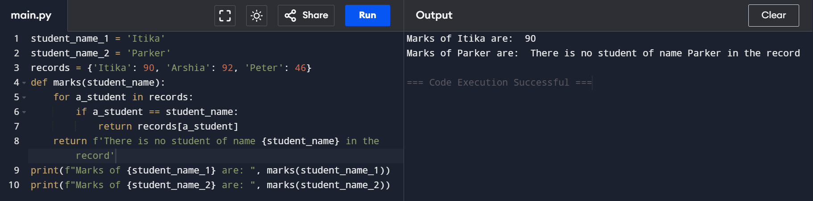

Nested loops

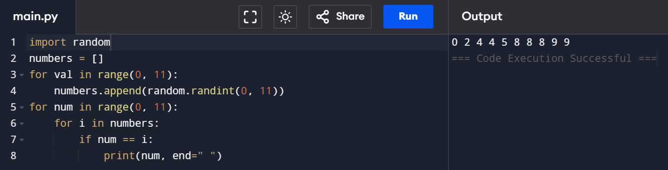

while loops in Python for printing numbers from 1 to 10

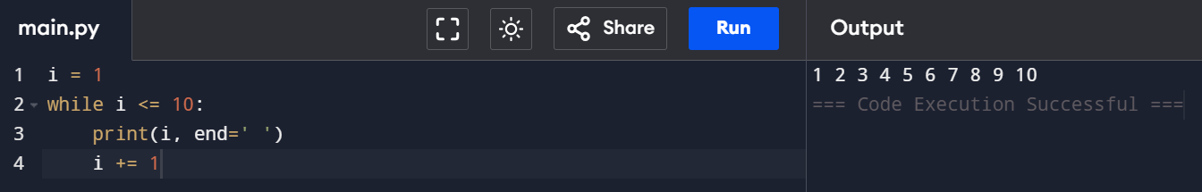

while loops in Python for Printing those numbers divisible by either 5 or 7 within 1 to 50

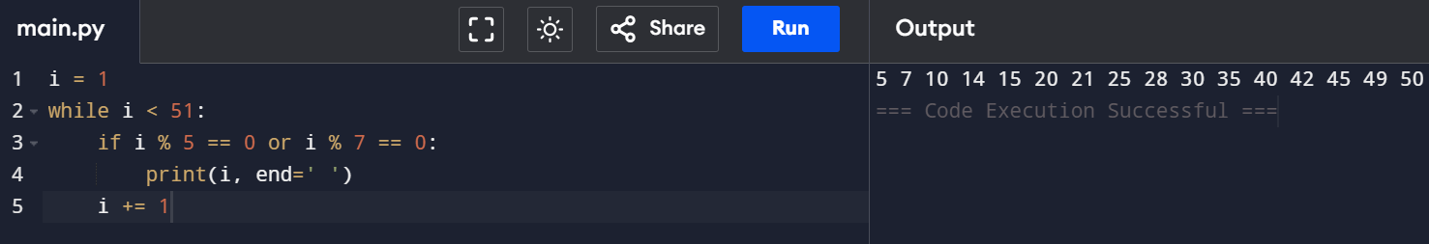

the sum of squares of the first 15 natural numbers using a while loop.

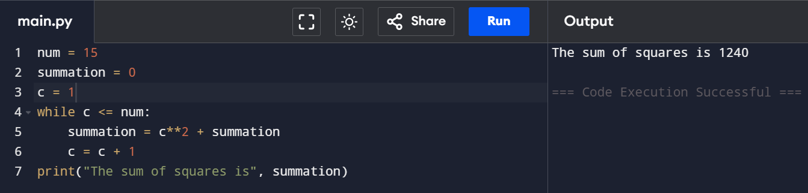

while loops in Python for a number is Prime number or not.

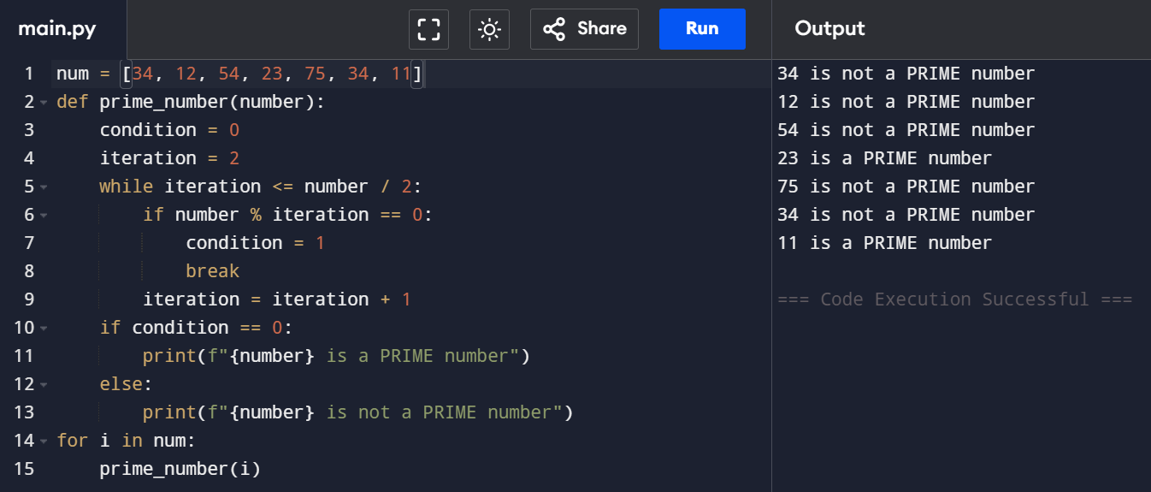

while loops in Python for a number is Armstrong number or not.

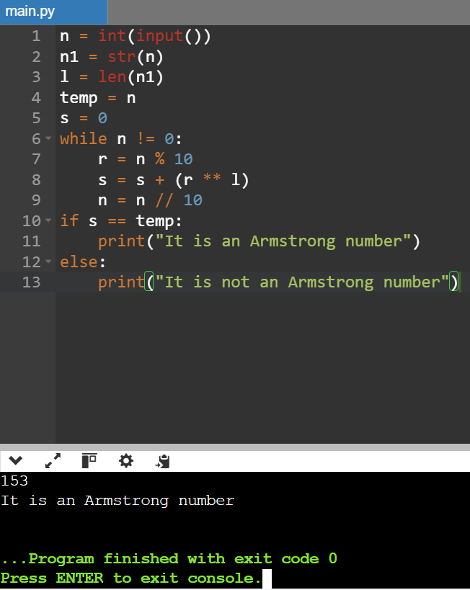

while loop for printing the multiplication table of a given number.

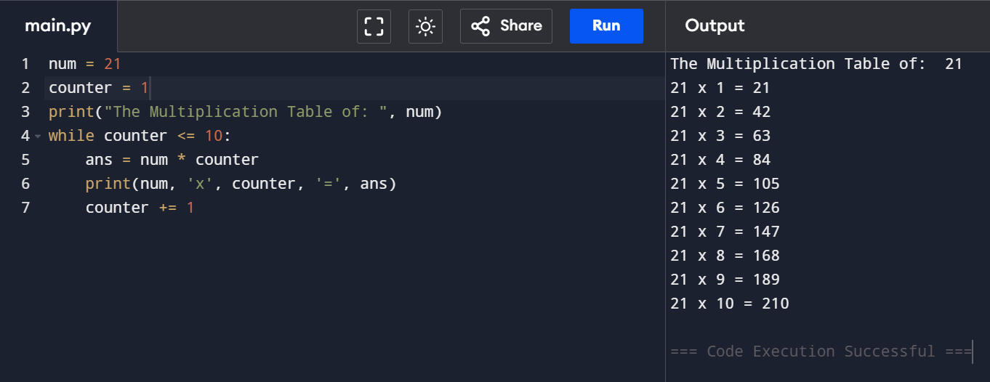

while loops in Python for square every number of a list

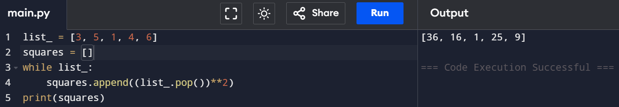

while loops in Python for determine odd and even number from every number of a list

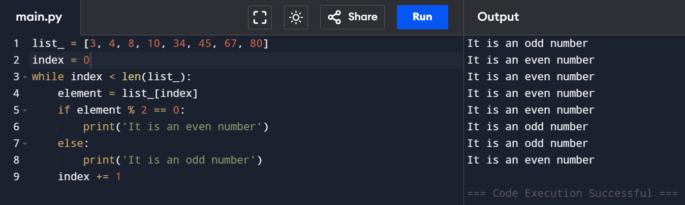

while loops in Python for determine the number letters of every word from the given list.

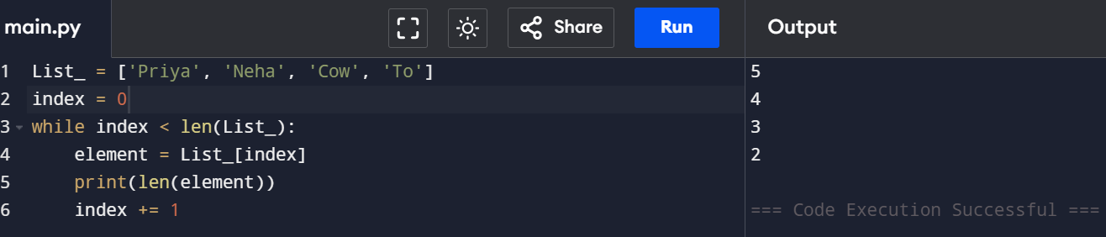

while loops in Python for multiple condition.

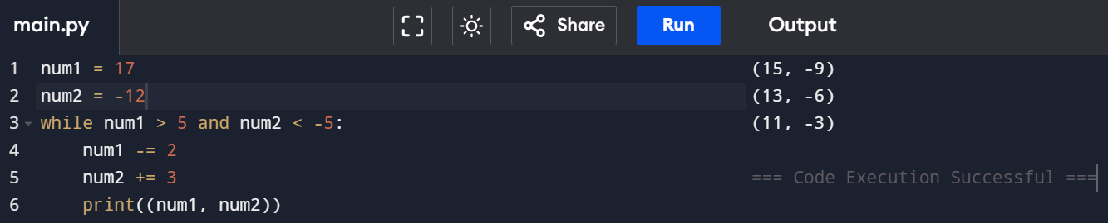

break statement with for loop

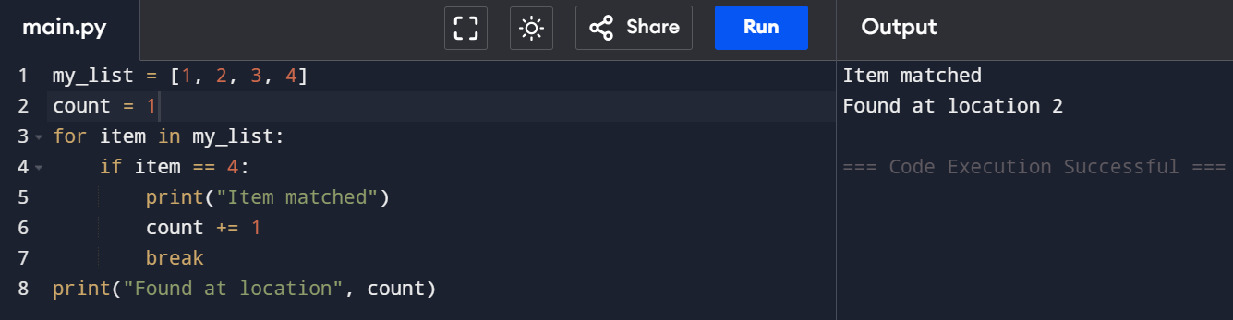

Breaking out of a loop early

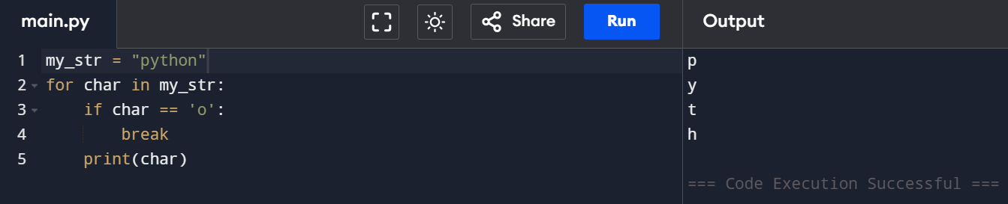

break statement with while loop

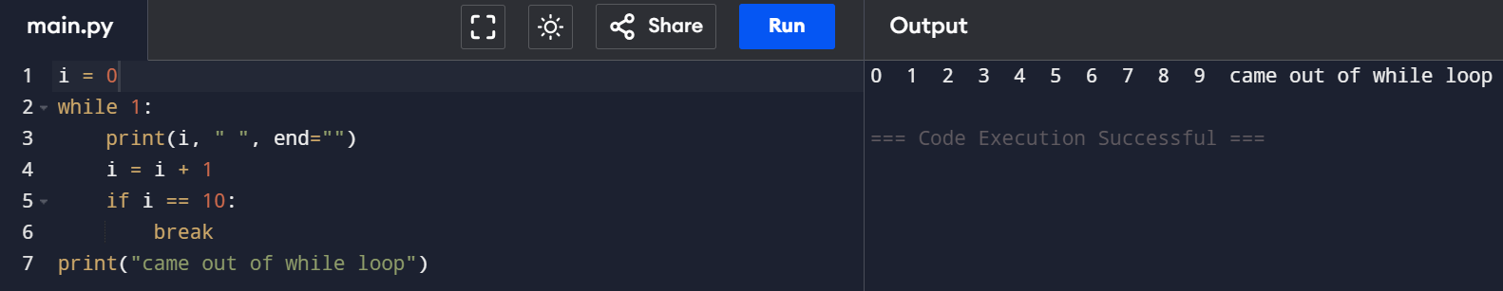

break statement with nested loops

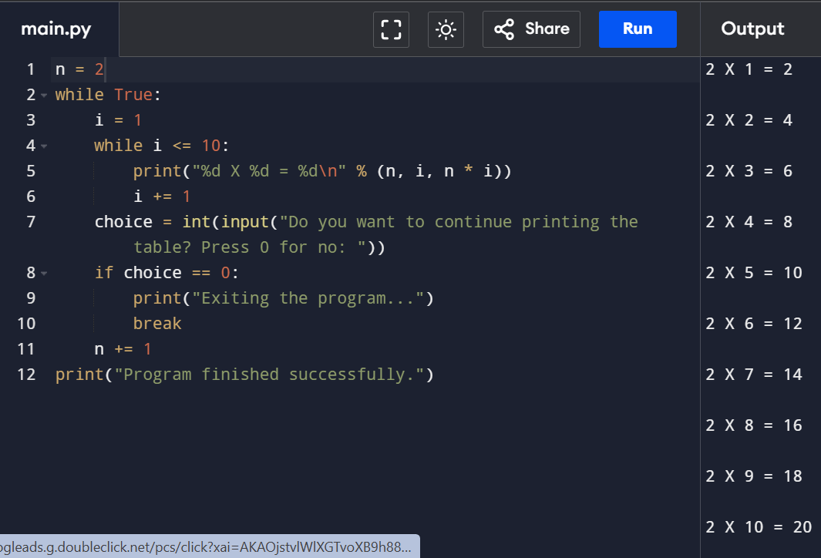

Python Continue Statements in while Loop

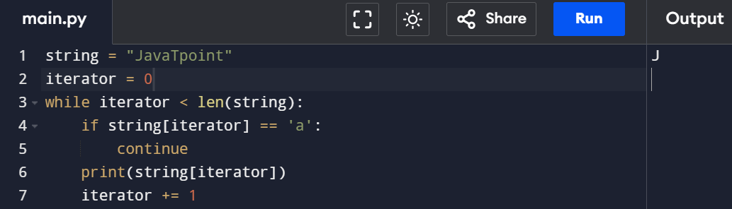

Python Continue statement in list comprehension

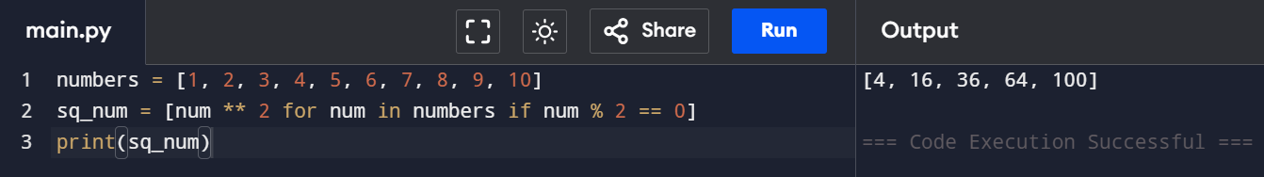

Creating String in Python

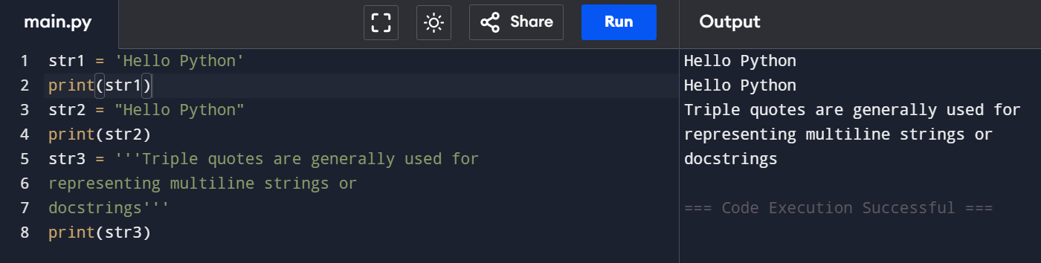

Strings indexing and splitting

Example 1

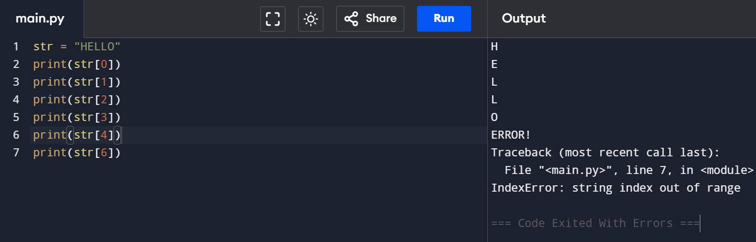

Example 2

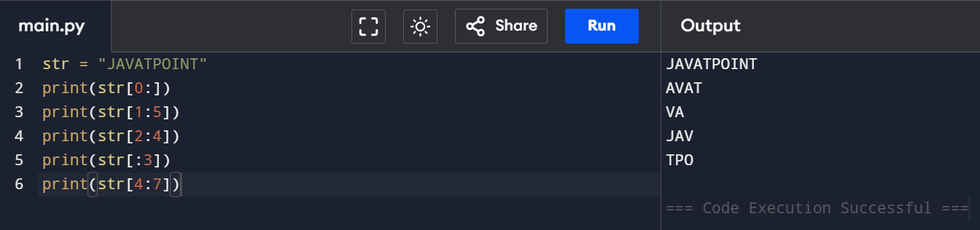

Reverse

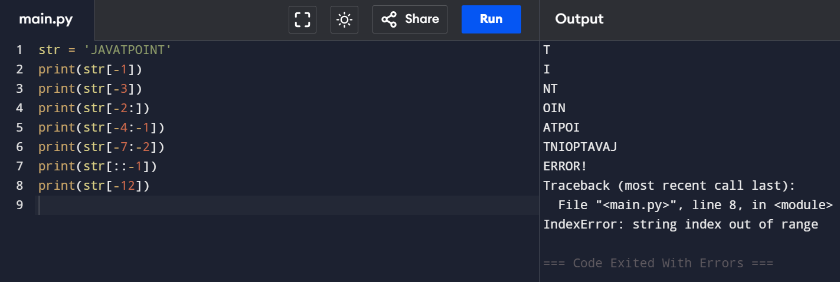

Reassigning Strings

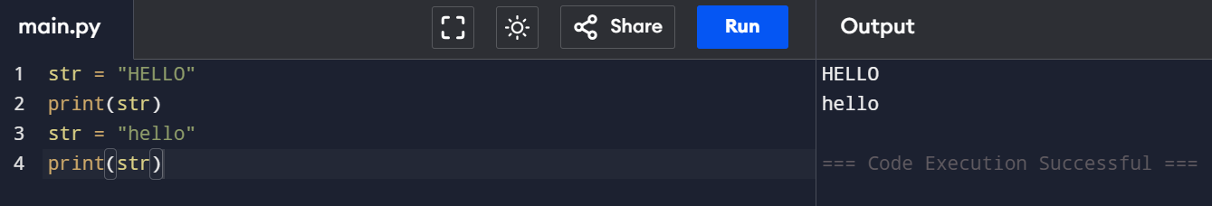

Deleting the String

Deleting a string

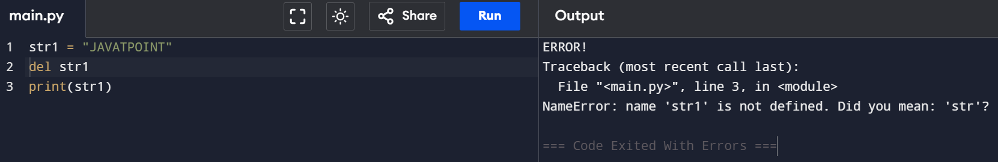

use of Python operators

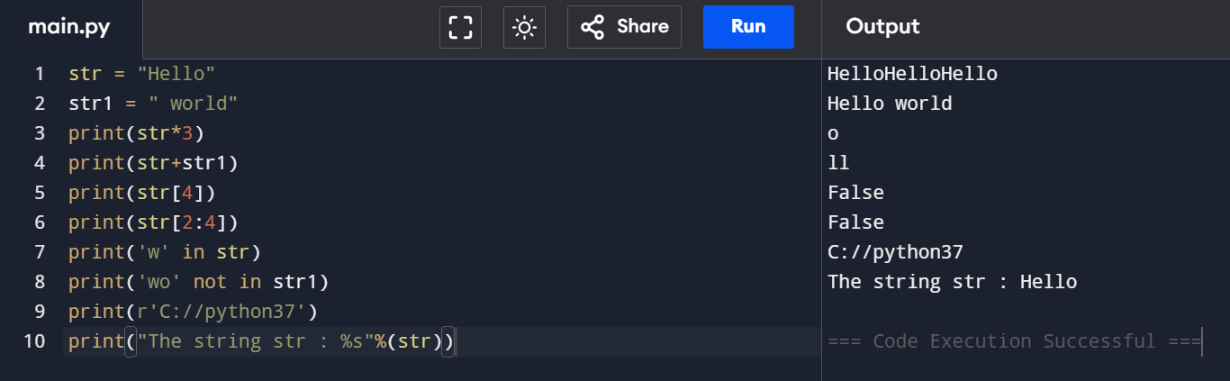

Escape Sequence

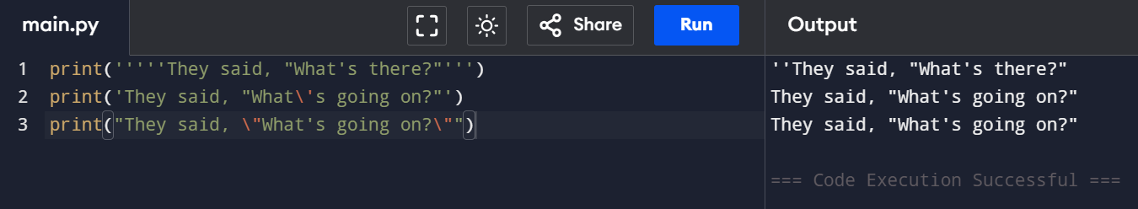

The format() method

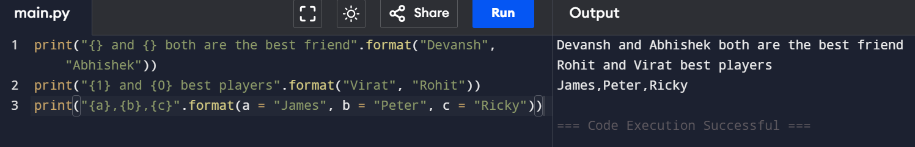

Python String Formatting Using % Operator

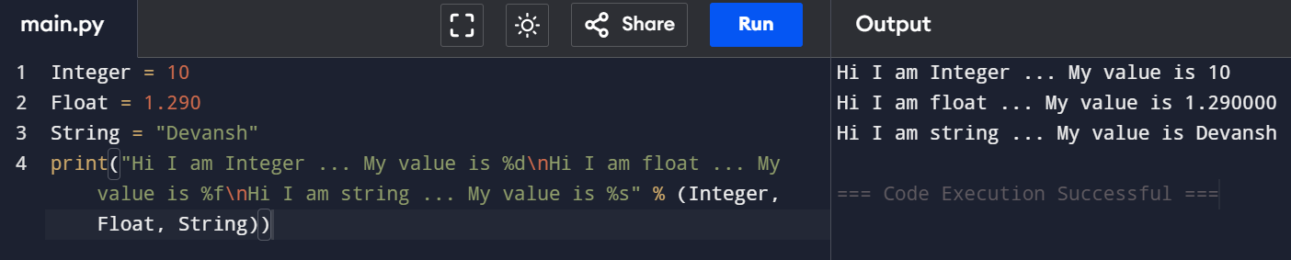

Python code to show the difference between creating a list and a tuple

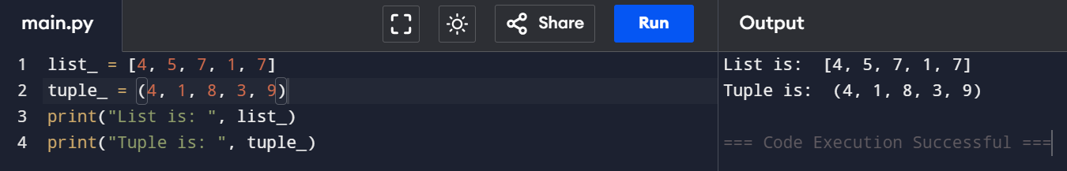

Updating the element of list and tuple at a particular index

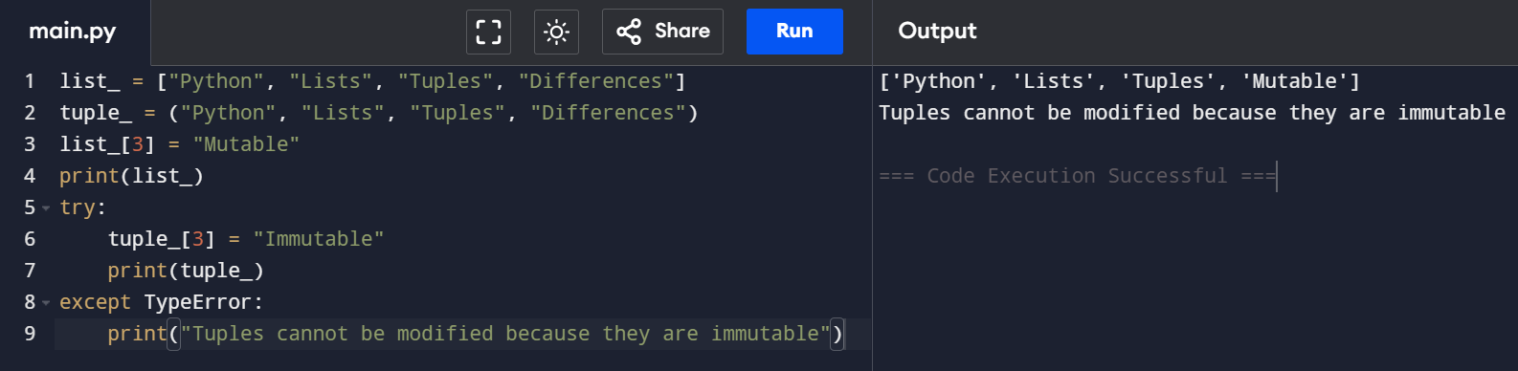

Code to show the difference in the size of a list and a tuple

